Lab 14 – .NET - Dev - Configuring your App Service or Azure Functions app to use Entra ID login
Estimated duration: 15 minutes
Lab Type: Instructor led
Objective
In this lab, you will learn how to enable authentication for your web app running on Azure App Service and limit access to users in your organization.

Exercise 1: Configure authentication and authorization
- You have a web app running on App Service.
- To enable authentication and authorization, you use Azure AD as the identity provider.
- From the Azure portal, navigate to the Resource group RGForAppService and select the App Service dotNetAzureWebAppXX.
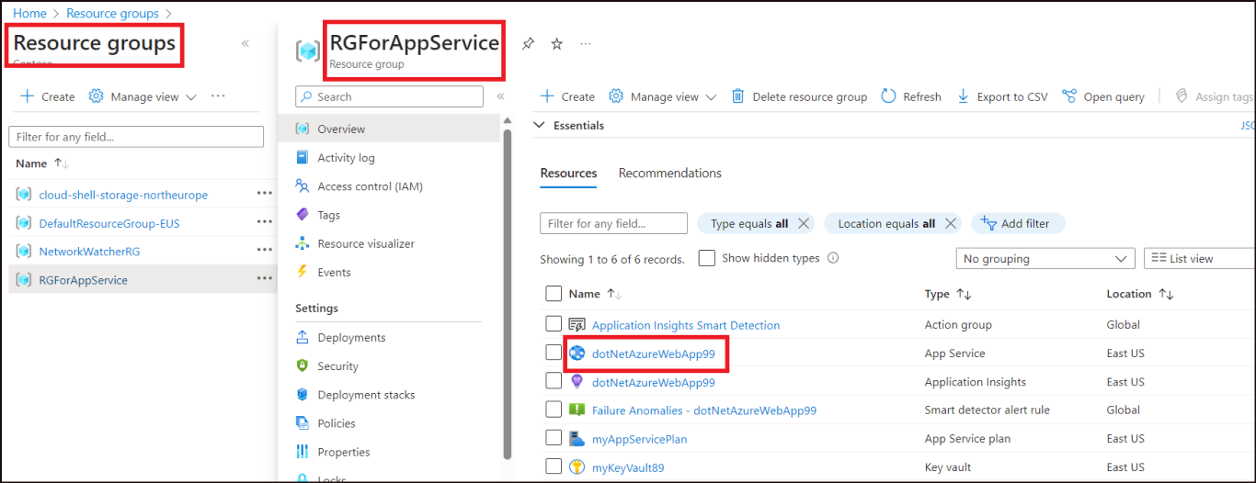
- Click on Authentication from the left pane and then select Add identity provider.
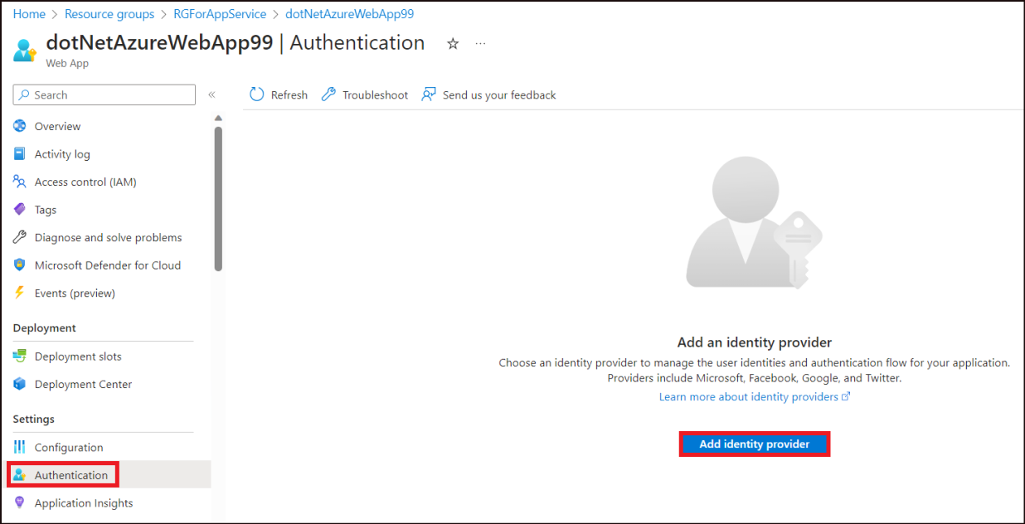
- On the Add an identity provider page, select the below details and click on Add.
Property | Value
Identity provider | Microsoft
Tenant type | Workforce
App registration type | Create new app registration
Name | Todoapp
Supported account types | Current tenant – Single tenant
Restrict access | Require authentication
Unauthorized requests | HTTP 302 Found redirect: recommended for websites
- 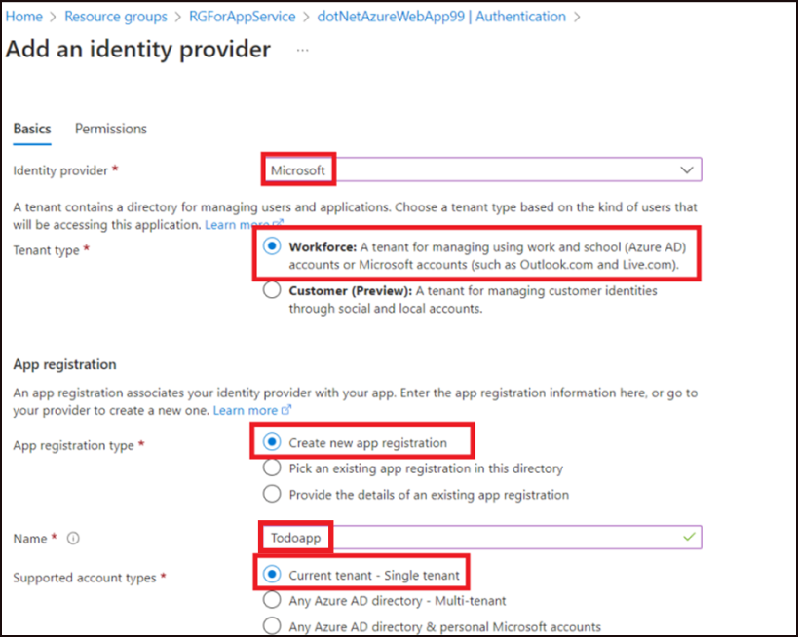
- 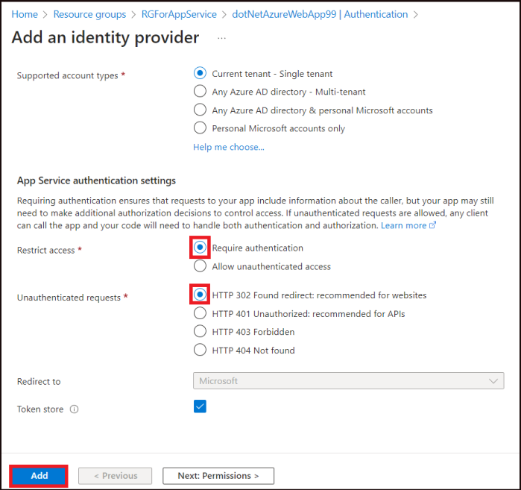
- You get a success message stating that the identity provider has been added.
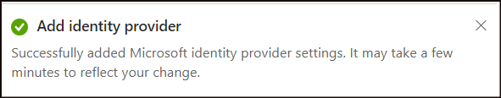
- You now have an app that's secured by the App Service authentication and authorization.

Exercise 2: Verify limited access to the web app
- When you enabled the App Service authentication/authorization module in the previous exercise, an app registration was created in your Azure AD tenant.
- To check the settings, Type App regi in the search bar of the Azure Home page and select App registrations.
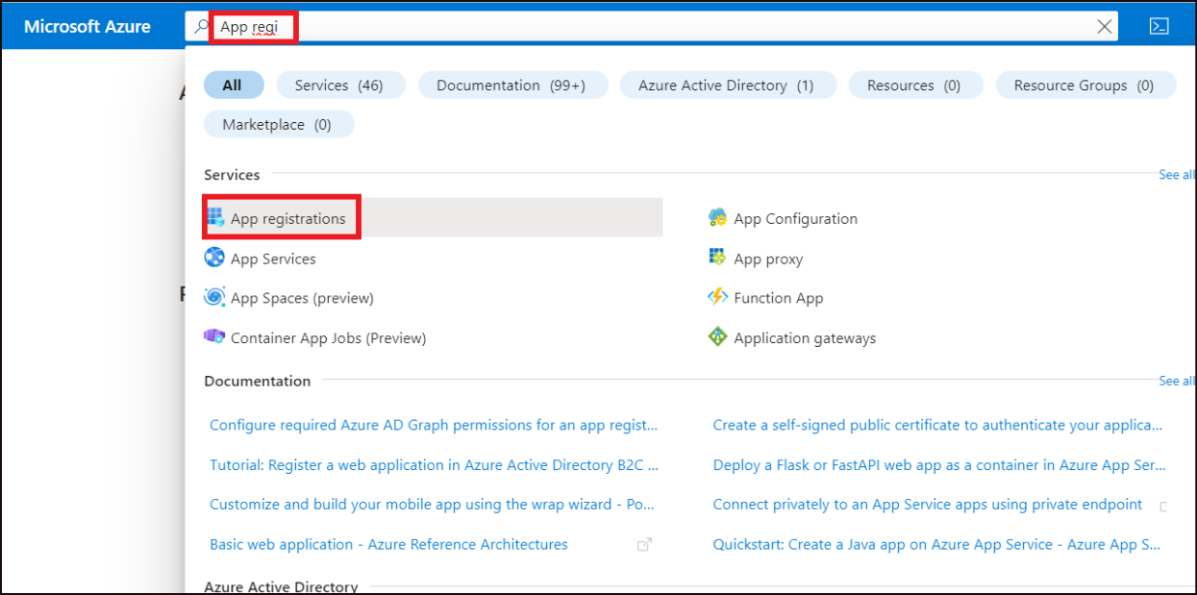
- On the App registrations page, select All applications. You can find the created Todoapp under it. Click on it.
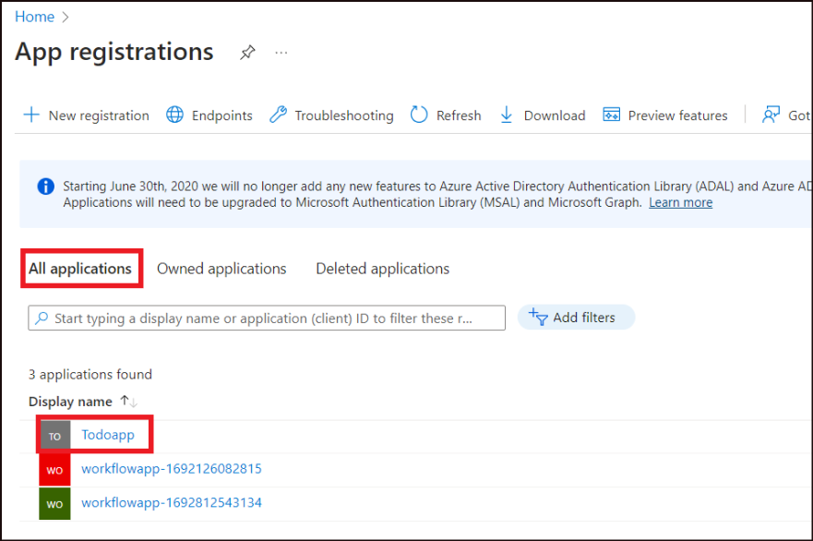
- In the overview page, verify that Supported account types is set to My organization only.
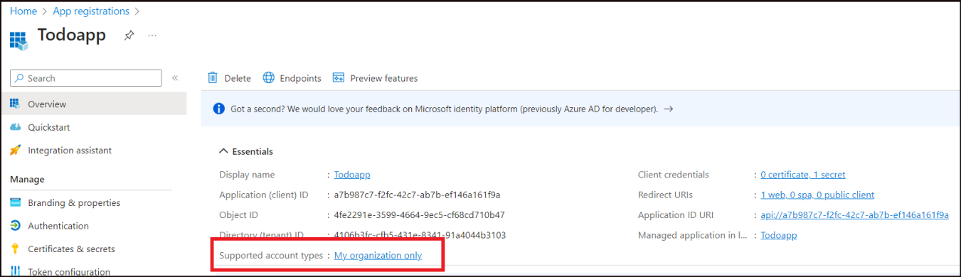
- Now, open the Web app and click on the Default domain to access the app.
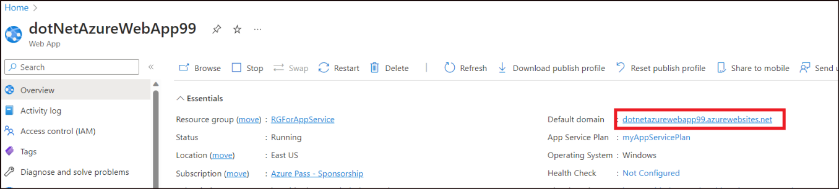
- You will be directed to a secured sign-in page, verifying that unauthenticated users aren't allowed access to the site. Sign in with your tenant id.
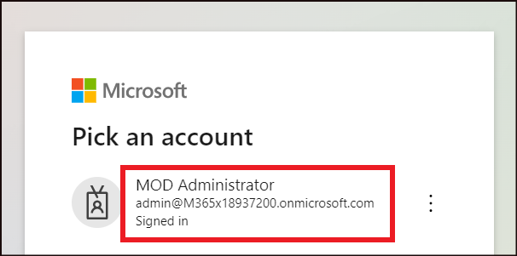
- Select the option, Consent on behalf of your organization and then click on Accept.
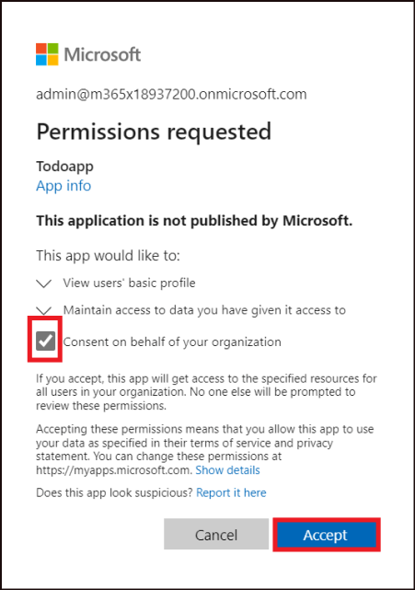
- You will now be directed to the Todo application.
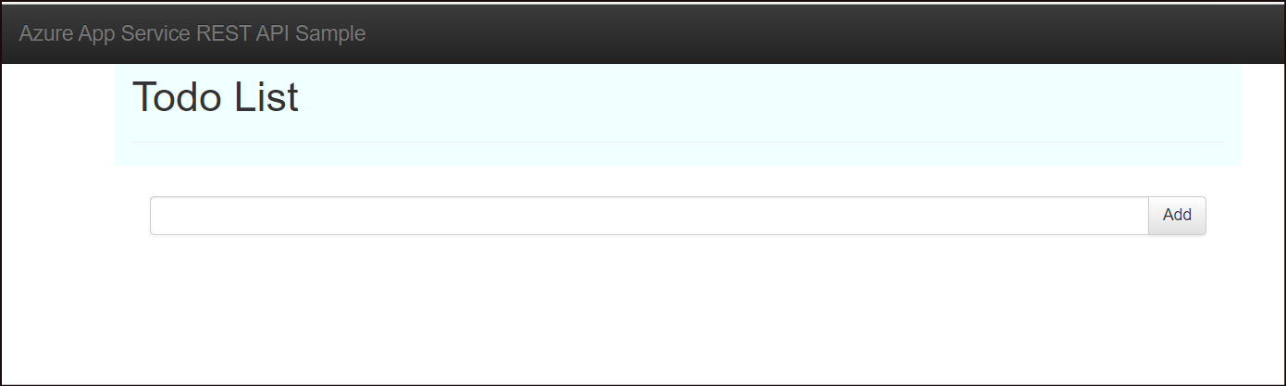

Exercise 3: Clean up resources

Task 1: Delete the Resource group
- From the Azure portal, select the Resource group RGForAppService. Click on Delete resource group.
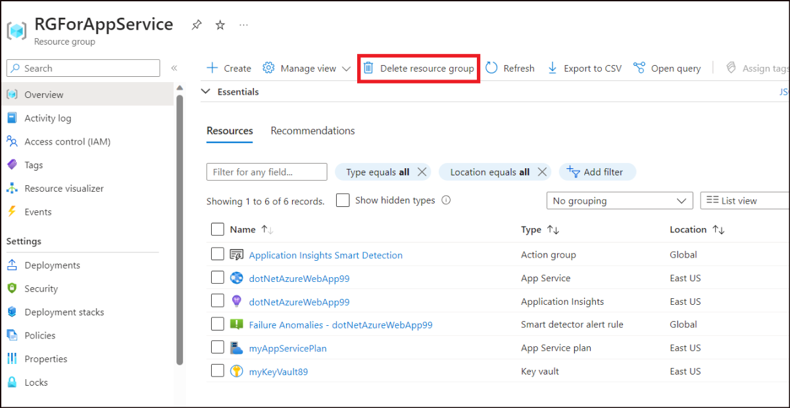
- Type in the RGForAppService and click on Delete.
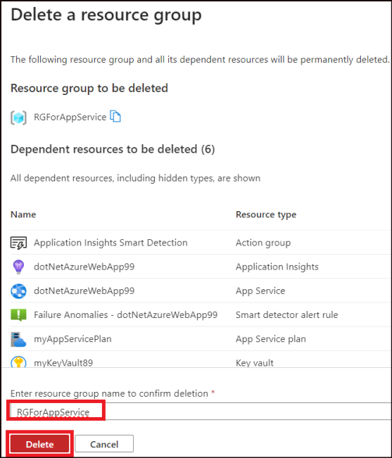
- Click on Delete on the confirmation dialog box.
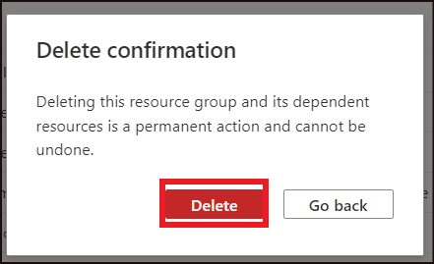

Task 2: Delete the app registration
- From the Home page of the Azure portal, type in App registration in the search bar, and select App registrations.
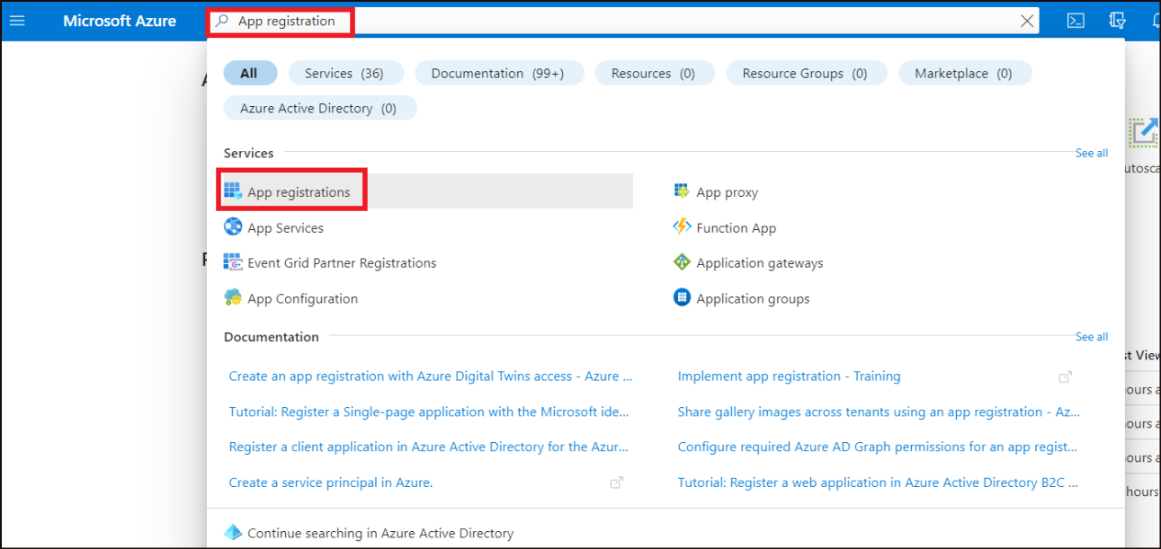
- Select the application you created.
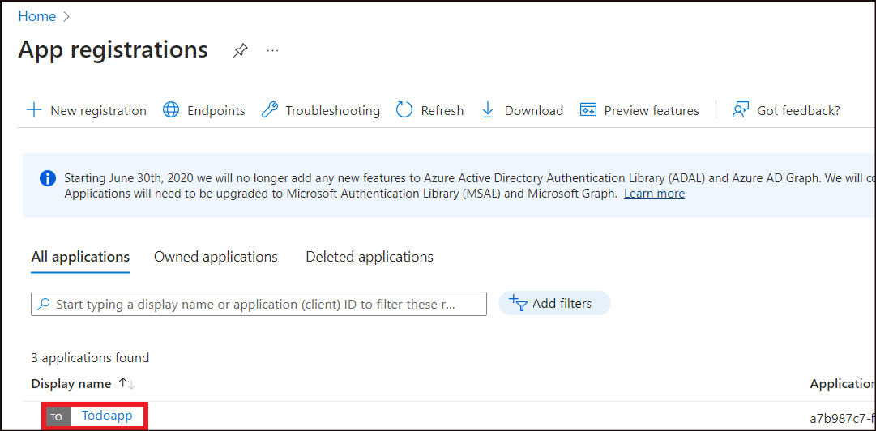
- Click on Delete.
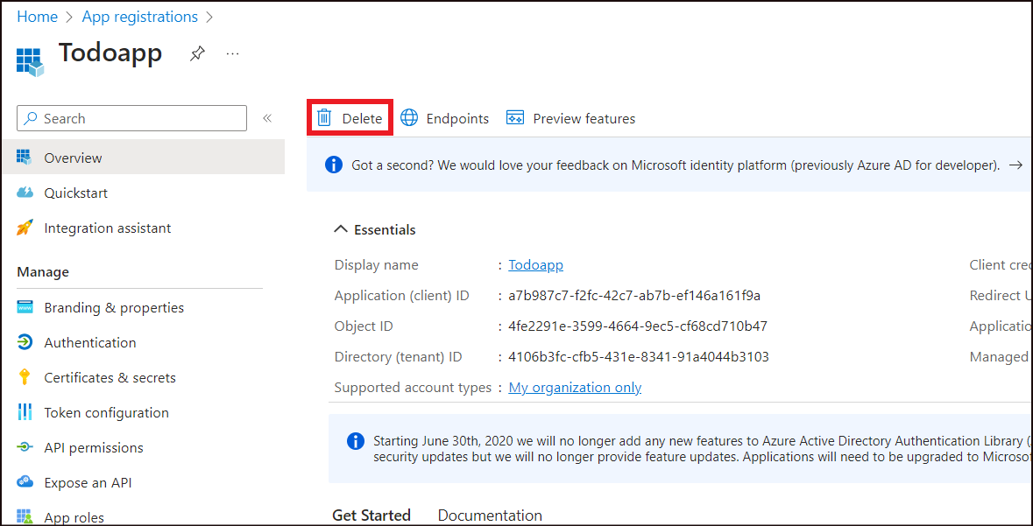
- Select the check box of I understand the implications and click on Delete.
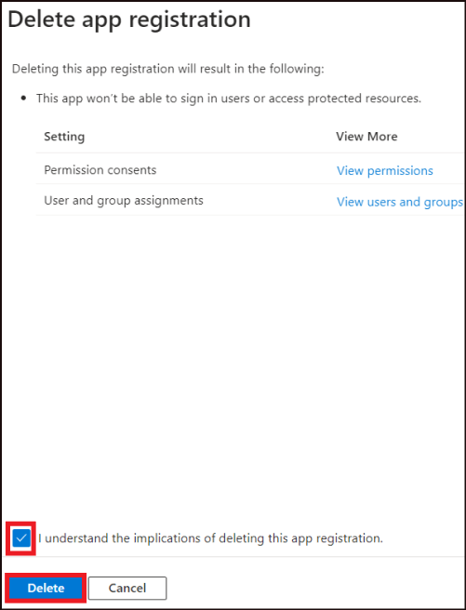
Summary
In this lab, you have learnt to add app authentication to your web app running on Azure App Service

